CARD 10
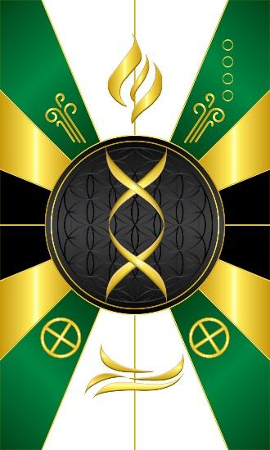
Card 10 is Geb, the earth God. To the Kamau, Geb was the Erpau Neter, meaning literally the inheritor of God, and meaning more properly that the physical body inherits the qualities and attributes of all the deities: "as above, so below." That is, the physical body "inherits" or reflects the patterns of energy organization already present in the aspects of spirit represented by the other deities. This is represented by the symbols of the four elements. Fire at the top, water at the bottom, Air in the upper corners, and the glyph for the Earth in the lower corners. In the middle are two DNA strands coming together to form a bond and represents matter, concrete physical things. However, energy and matter are not separate, but opposite ends of the same thing. Energy and Matter are connected, changes in energy result in changes in matter. The main color is green to represent the vegetation and foliage of the earth.

Comments by Baba Awodele

